RESUME
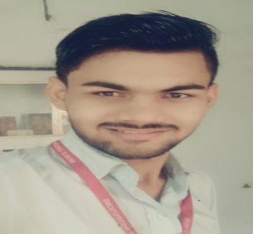
Rajan N. Gajera (B.E. mech.)
To:- Ankleshwar
Ta:- Ankleshwar, Dist:-Bharuch
Pin Code No.:- 393002
Mo:- +91 7600663878
Email ID:- rajangajera039@gmail.com

CAREER OBJECTIVE

- To work in a firm with a professional work driven environment where, I can utilize and apply my knowledge, skills, which would enable me as a graduate Mechanical Engineering to grow while fulfilling Organizational goals.

COTRIBUTOR PROFILE

- Have a passion to share an idea, knowledge, and experience with everyone.
- Have a good decision power and without more time disipassion.
- I can work are perform honestly, and motivate the team member.

AREA OF INTEREST

- Manufacturing.
- Production.
- Quality control.

ACADEMIC&PROFESSIONAL QUALIFICATION

Course | School/College | Board/University | Year | P.R/CGPA
B.E.  (Mech) | Noble Group of Institute junagadh | GTU | 2017 | 8.58  (CGPA)
H.S.C | Krishana science school, Amreli | G.S.H.S.E.B. | 2013 | 75.49  P.R
S.S.C | Om International school  Kumbhariya | G.S.E.B. | 2011 | 94.88  P.R

PROJECTS

- Design And Analysis of Leaf Spring
- Solar Refrigenaration

EXTRA –CURRICULAR ACTIVITIE

- Actively participated in various Technical and Non Technical events in school and college.
- Also I have project work are perfome in anand engineering rajkot.

INDUSTRIAL VISITS
- Had an industrial visit to following companies:-
- S.T.Worksop in Rajkot.
- Amul industries in Rajkot.
- Parth industries aji GIDC Rajkot.

STRENGTH & SKILLS

- Basic Auto Cad.
- Basic MS office & C language.
- Basic knowledge of lathe,drilling.
PERSONAL DETAILS

- Date of Birth : 21 Aug 1996
- Gender : Male
- Blood Group : A+
- Language Known : English , Hindi, Gujarati
- Marital Status : Single
- Nationality/Religion : Indian / Hindu.
- Interest & Hobbies : Playing cricket,solving puzzle,study
- Passport Visibility : Process Continue

DECLARATION

I am sincere in all my endeavors and have a good coordination skill to work in a team. I hereby declare that above mentioned information is correct up to my knowledge and I bear the responsibility for the correction of the above particulars.

Yours Faithfully
Date :-
Place:- RAJAN N GAJERA

